Name-Aditi Sudhir Igade

Div-A Roll no-221081

PRN. No-22220311

Assignment -5

**PROBLEM STATEMENT: -**

Create User defined exception to check the following conditions and throw the exception if the criterion does not meet. a. User stays in Pune/ Mumbai/ Bangalore / Chennai City, b. User has 4-wheeler, Vehicle. If any of the condition not met then throw the exception. If user does not enter proper input throw the exception.

**OBJECTIVE: -**

To understand concepts of exception handling in java and to write a java program to implement user defined exception handling.

## THEORY:-

The **Exception Handling in Java** is one of the powerful *mechanism to handle the runtime errors* so that the normal flow of the application can be maintained.

In Java, an exception is an event that disrupts the normal flow of the program. It is an object which is thrown at runtime.Exception Handling is a mechanism to handle runtime errors such as ClassNotFoundException, IOException, SQLException, RemoteException, etc. The core advantage of exception handling is **to maintain the normal flow of the application**. An exception normally disrupts the normal flow of the application; that is why we need to handle exceptions.

Hierarchy of Java Exception classes. The java.lang.Throwable class is the root class of Java Exception hierarchy inherited by two subclasses: Exception and Error.

**ALGORITHM: -**

1.Create a Class UserDefinedException that extends class Exception.

2.Write the methods for userdefined exceptions.

3.Create a class that uses userdefined exceptions.

**Code-**

import java.util.Scanner;

class cal extends RuntimeException{

cal(String ss){

super(ss);

}

}

class cal1 extends RuntimeException{

cal1(String ss1){

super(ss1);

}

}

class Main{

public static void main(String[] args) {

Scanner sc=new Scanner(System.in);

System.out.println("Enter no. of wheeler car");

int n=sc.nextInt();

System.out.println("Enter the city");

String s=sc.next();

try{

if(s.equals("Pune")||s.equals("pune")||s.equals("Mumbai")||s.equals("mumbai")||s.equals("Chennai")||s.equals("chennai")||s.equals("Banglore")||s.equals("bangore")){

System.out.println("The entered city is correct");

}

else{

throw new cal("The entered city is wrong");

}

}

catch(Exception e) {

e.printStackTrace();

}

finally{

try{

if(n==4){

System.out.println("The number of wheeler is correct");

}

else{

throw new cal1("The Entered number is not correct");

}

}

catch (Exception e) {

e.printStackTrace();

}

}

}

}

**Output-**

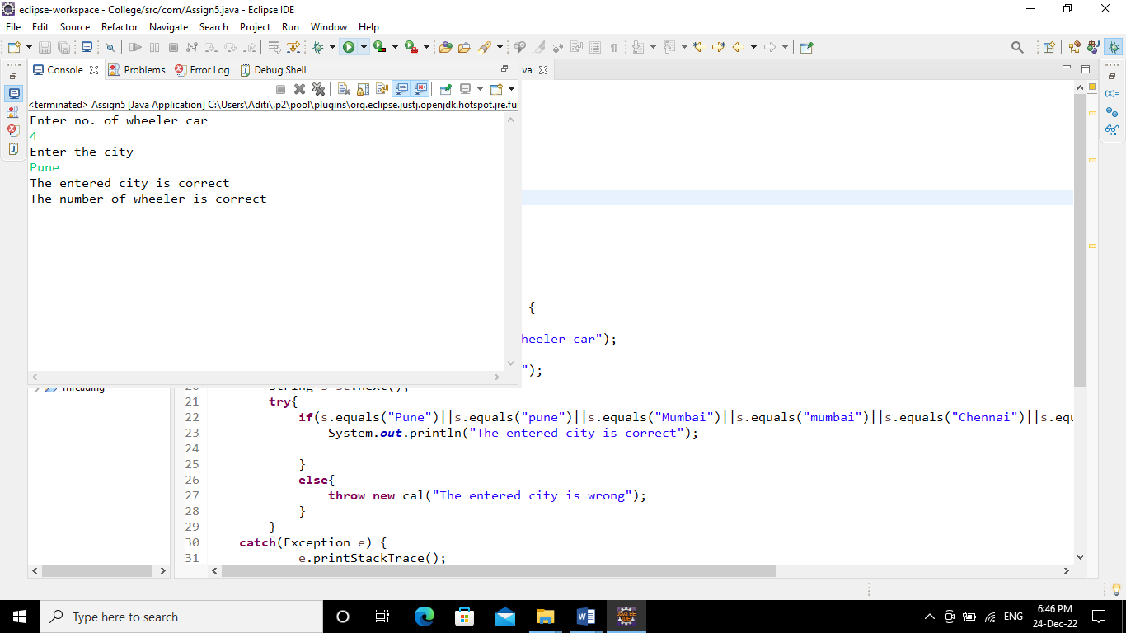

**Conclusion-** Able to understand and apply the object oriented concept of exception handling